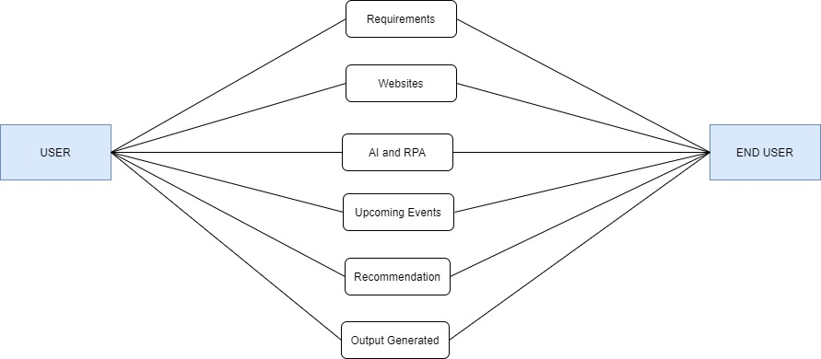

RECOMMENDATION

END USER

USER